**Introduction**

WeRateDogs ([@dog_rates](https://twitter.com/dog_rates)) is a Twitter handle that rates people's dogs with a humorous comment about the dog. These ratings almost always have a denominator of 10. The numerator is generally always greater than 10.

The Insights reported in this document have been arrived after data wrangling and analysing the following artefacts:

1. The enhanced twitter archives of WeRateDogs - [twitter_archive_enhanced.csv](https://d17h27t6h515a5.cloudfront.net/topher/2017/August/59a4e958_twitter-archive-enhanced/twitter-archive-enhanced.csv)
2. Additional relevant data downloaded from Twitter using Twitter API.
3. The tweet image predictions file (image_predictions.tsv) which contains a prediction of the breed of dog (or other object, animal, etc.) present in each tweet picture.

**Insights**

#### Insight # 1

* The average 'numerator ratings' per month for the dogs have gradually increased month over month - Trending up This could mean that ratings may have become a bit liberal as the time progressed.
* Also there is a change in strategy to start numerator rating from 10 onwards after the first month.
* The favorite_count per month also look to be generally increasing month over month

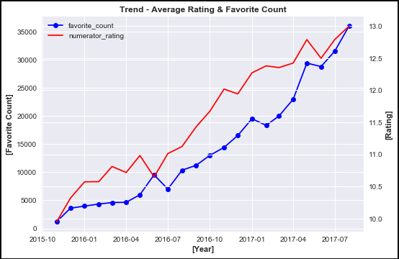

#### Insight # 2

* The top 5 rated dog breeds are (starting highest) - Pembroke ,Samoyed, chow, Golden Retriever, Cardigan
* The bottom 5 rated dog breeds are (starting lowest)- Maltese dog, Pug ,Shetland sheepdog, German Shepherd, Chihuahua

**Top 5 dog breeds on the basis of their average numerator ratings/dog breed**

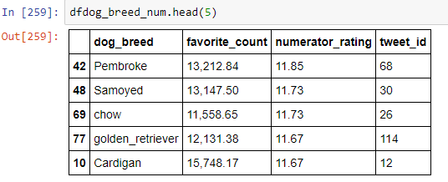

**Bottom 5 dog breeds on the basis of their average numerator ratings/dog breed**

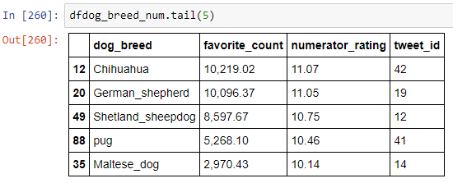

**Visual Plot**

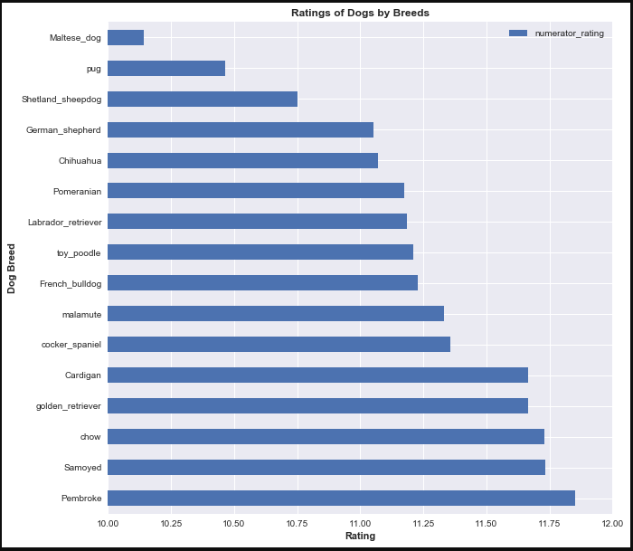

#### Insight 3

* The top 5 most liked dog breeds are (starting highest) - French Bulldog , Cardigan, Labrador Retriever, Pembroke and Samoyed
* The bottom 5 liked dog breeds are (starting lowest)- Maltese dog, Pug ,Toy Poodle, Pomeranian and Shetland Sheepdog
* Pembroke, Samoyed and Cardigan are common in the top 5 ratings and Favorites
* Maltese dog, Pug, Shetland Sheepdog are common in the bottom 5 ratings and Favorites

**Top 5 breeds on the basis of Favorite counts in Twitter / Dog breed**

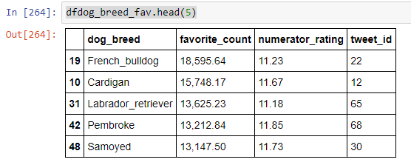

**Bottom 5 breeds on the basis of Favorite counts in Twitter/ Dog breed**

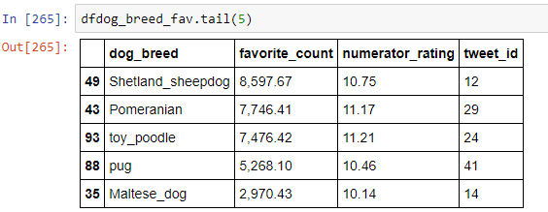

**Visual Plot**

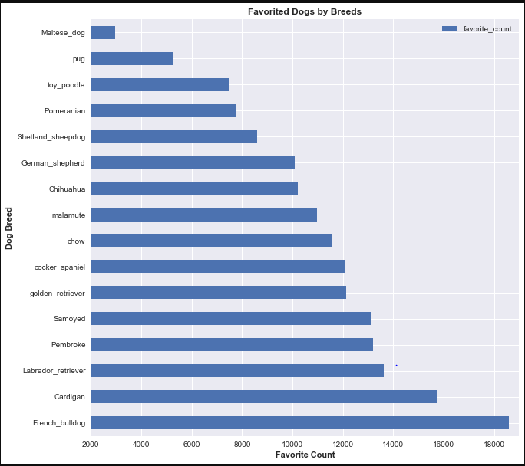

#### VISUALIZATION

###### **Correlation Heat map**

* This figure shows the correlation between different features of the Project data set
* We can see a strong correlation (0.92) between retweet count and favorite count
* There doesn't seem to be a strong correlation between the numerator rating and favorite count and retweet count

1. **Correlation Heat map Plot**

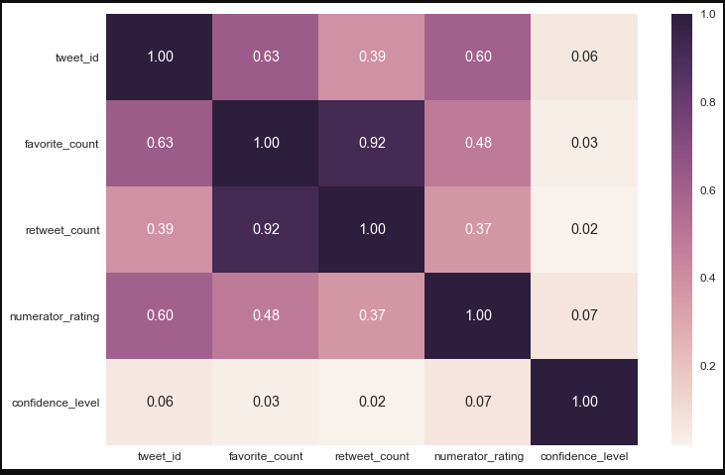

1. **Validating the correlation between Average Rating and Favorite Count**

